A PRELIMINARY REPORT
ON

Rakshak: AI-Driven Companion for Women’s Safety

SUBMITTED TO THE SAVITRIBAI PHULE PUNE UNIVERSITY, PUNE
IN THE PARTIAL FULFILLMENT OF THE REQUIREMENTS
FOR THE AWARD OF THE DEGREE

OF

BACHELOR OF ENGINEERING (ARTIFICIAL INTELLIGENCE AND DATA SCIENCE)

SUBMITTED BY

STUDENT NAME EXAM SEAT NO:

Sujit Manojrao Nirmal
Soham Gulhane
Suhani Yadav
Swarup Mandhare



DEPARTMENT OF ARTIFICIAL INTELLIGENCE AND DATA SCIENCE

DR. D. Y. PATIL INSTITUTE OF ENGINEERING, MANAGEMENT & RESEARCH

AKURDI, PUNE 411044

SAVITRIBAI PHULE PUNE UNIVERSITY
2025-2026
CERTIFICATE

This is to certify that the project report entitles

“Rakshak: AI-Driven Companion for Women’s Safety”

Submitted by

STUDENT NAME EXAM SEAT NO
Sujit Manojrao Nirmal
Soham Gulhane
Suhani Yada
Swarup Mandhare

is a bonafide student of this institute and the work has been carried out by him/her under the supervision of Dr. Suvarna Patil and it is approved for the partial fulfillment of the requirement of Savitribai Phule Pune University, for the award of the degree of Bachelor of Engineering (Artificial Intelligence and Data Science).

Mrs. Surbhi Pagar Dr. Suvarna Patil
Guide HOD
Department of AI&DS Department of AI&DS

Dr. Anupama V. Patil
Principal,
Dr. D. Y. Patil Institute of Engineering, Management & Research Akurdi Pune – 41

Place: Pune
Date:
ACKNOWLEDGEMENT

It gives us great pleasure in presenting the preliminary project report on ‘AntarAalay.ai: AI-Powered Vastu Interior Design Platform’.

I would like to take this opportunity to thank my internal guide Dr. Suvarna Patil for giving me all the help and guidance I needed. I am really grateful to them for their kind support. Their valuable suggestions were very helpful.

I am also grateful to Dr. Suvarna Patil, Head of Artificial Intelligence & Data Science Department, Dr. D. Y. Patil Institute of Engineering, Management & Research for his indispensable support, suggestions.

In the end our special thanks to Mrs. Sneha Kanawade for providing various resources such as laboratory with all needed software platforms, continuous guidance, for Our Project.

Name of Student Sign
Sujit Manojrao Nirmal
Soham Gulhane
Suhani Yadav
Swarup Mandhare
(BE Artificial Intelligence and Data Science)

ABSTRACT

AntarAalay is an innovative AI-powered interior design application developed using modern web technologies, aimed at providing a comprehensive solution for intelligent space planning with a particular focus on Vastu Shastra compliance. Unlike conventional interior design applications that rely primarily on manual inputs and basic visualization tools, AntarAalay incorporates an intelligent, multi-layered design system capable of generating personalized interior layouts through multiple modalities such as room scanning, preference analysis, and Vastu principle integration. This flexibility ensures that users can create harmonious living spaces even without extensive design knowledge or architectural expertise. To maintain cultural authenticity while embracing modern design trends, the application integrates AI-powered Vastu compliance checking along with real-time 3D visualization and personalized design recommendations. AntarAalay leverages advanced machine learning algorithms for precise room analysis and layout optimization, Firebase for real-time collaboration features, and an intuitive user interface for seamless design experience. By combining AI-powered interior intelligence, traditional Vastu wisdom, and modern visualization capabilities, AntarAalay offers a responsive, culturally-aware, and user-friendly platform designed to transform interior design processes and create balanced living spaces that enhance well-being and prosperity in real-world applications.

Keywords: AI-powered design, Vastu compliance system, room analysis recognition, preference recognition, 3D layout generation, offline design tools, real-time visualization, interior harmony optimization

TABLE OF CONTENTS

LIST OF ABBREVATIONS i
LIST OF FIGURES ii
LIST OF TABLES iii

Sr. No. |  |  | Title of Chapter |  | Page No.
1 |  |  | Introduction |  | 10
 | 1.1 |  | Overview |  | 10
 | 1.2 |  | Motivation |  | 10
 | 1.3 |  | Problem Definition and Objectives |  | 10
 | 1.4 |  | Project Scope & Limitations |  | 10
2 |  |  | Literature Survey |  | 13
3 |  |  | Software Requirements Specification |  | 18
 |  | 3.1 | Introduction |  | 18
 |  |  | 3.1.1 | Project Scope
 |  |  | 3.1.2 | Use Classes and Characteristics
 |  |  | 3.1.3 | Assumptions and Dependencies
 |  | 3.2 | Functional Requirements |  | 19
 |  | 3.3 | External Interface Requirements |  | 19
 |  |  | 3.3.1 | User Interfaces
 |  |  | 3.3.2 | Hardware Interfaces
 |  |  | 3.3.3 | Software Interfaces
 |  |  | 3.3.4 | Communication Interfaces
 |  | 3.4 | Non-functional Requirements |  | 20
 |  |  | 3.4.1 | Performance Requirements
 |  |  | 3.4.2 | Safety Requirements
 |  |  | 3.4.3 | Security Requirements
 |  |  | 3.4.4 | Software Quality Assurance
 |  | 3.5 | System Requirements |  | 21
 |  |  | 3.5.1 | Database Requirements
 |  |  | 3.5.2 | Software Requirements (Platform Choice)
 |  |  | 3.5.3 | Hardware Requirements
 |  | 3.6 | Analysis Models: SDLC Model to be applied |  | 23
 |  | 3.7 | System Implementation Plan |  | 24
4 |  |  | System Design |  | 26
 |  | 4.1 | System Architecture |  | 26
 |  | 4.2 | Data Flow Diagrams |  | 26
 |  | 4.3 | Entity Relationship Diagrams |  | 28
 |  | 4.4 | UML Diagrams |  | 29
 |  | 4.5 | Sequence Diagram |  | 29
 |  | 4.6 | Activity Diagram |  | 30
5 |  |  | Other Specification |  | 31
 |  | 5.1 | Advantages |  | 31
 |  | 5.2 | Limitations |  | 31
 |  | 5.3 | Applications |  | 31
6 |  |  | Conclusions & Future Work |  | 32
7 |  |  | References |  | 33

LIST OF ABBREVATIONS

ABBREVIATION | ILUSTRATION
AI | Artificial Intelligence
SMS | Short Message Service
IoT | Internet of Things
GPS | Global Positioning System
SOS | Morse code distress signal
API | Application Programming Interface
XML | Extensible Markup Language
JWT | JSON Web Token
SDLC | Software Development Life Cycle
UI | User Interface
CCTV | Closed-Circuit Television
HTTPS | Hypertext Transfer Protocol Secure

LIST OF FIGURES
FIGURE | ILLUSTRATION | PAGE NO.
1 | AGILE SDLC | 21
2 | SYSTEM ARCHITECTURE | 26
3 | DFD LEVEL – 0 | 26
4 | DFD LEVEL – 1 | 27
5 | DFD LEVEL – 2 | 27
6 | ER DIAGRAM | 28
7 | UML DIAGRAM | 29
8 | SEQUENCE DIAGRAM | 29
9 | ACTIVITY DIAGRAM | 30
10 | LITERATURE REVIEW | 13

- INTRODUCTION

  - OVERVIEW
The AntarAalay – AI Powered Interior Design System is a web-based application developed to ensure harmonious living spaces through intelligent, real-time design optimization mechanisms. The system empowers users to generate personalized interior layouts via multiple modes, including room scanning, preference input, Vastu analysis, and style selection, ensuring optimal design solutions even in low-network or offline situations.
The application leverages Artificial Intelligence and Machine Learning for real-time space analysis, layout optimization, and cultural compliance recognition to provide proactive design measures. It integrates features such as collaborative design sharing, live 3D visualization and rendering ensuring rapid communication during design consultations. AntarAalay aims to overcome the limitations of conventional interior design applications that rely solely on manual design processes or constant internet connectivity. By combining AI-driven automation, offline design accessibility, and smart home integration, AntarAalay offers comprehensive interior design solutions that bridge traditional Vastu wisdom with modern aesthetic preferences.

  - MOTIVATION
The issue of harmonious living spaces has grown to become a significant global concern in recent years, calling for innovative and effective solutions that can respond promptly to design challenges. As technology advances, many interior design applications have been developed to address this issue, yet these often rely heavily on continuous internet connectivity and manual design processes, which may not be feasible in complex design scenarios or low-connectivity situations. Critical design decisions can be delayed when an application becomes difficult to use or inaccessible during such design consultations.
"AntarAalay" is designed to overcome these limitations by introducing an intelligent, AI-driven design solution that empowers users with swift, hands-free access to interior design support. The application integrates multiple input mechanisms—including room scanning, preference analysis, and Vastu compliance checking—to ensure reliable design generation in complex circumstances, even when users are inexperienced with design principles or unable to articulate their vision directly. AntarAalay further enhances user experience with features like 3D layout visualization,
By leveraging cutting-edge technology and AI, AntarAalay has the potential to foster greater public trust in automated design tools, promote widespread adoption of intelligent interior solutions, and open collaborative opportunities with architects, interior designers, and cultural preservation organizations. Its versatile design supports deployment across various settings—including residential use, commercial spaces, real estate staging, and low-network areas—ensuring its practical relevance and impact in creating harmonious living environments that honor traditional Vastu principles while embracing modern aesthetics.

  - PROBLEM STATEMENT AND OBJECTIVE
Problem Statement:
Despite recent advances in technology, harmonious interior design is still an essential concern. Existing design applications usually lack offline functionality, cultural responsiveness, and space-awareness. In complex design situations or in places with inadequate internet, users may not be able to properly access design assistance. A complete, multi-input, intelligent design system that works efficiently even when offline is apparently important.
Objectives:
- To develop an intelligent design app using AI to enable personalized interior layouts through multiple triggers like room scanning, preference analysis, and Vastu compliance checking.
- To integrate real-time 3D visualization and layout generation to help users visualize their exact design concepts instantly.
- To provide an offline design tool mechanism to ensure harmonious spaces can be created even without internet connectivity.
- To design a lightweight userfriendly interface that allows the fast and easy access for all users.

  - PROJECT SCOPE
AntarAalay covers the development of an AI-driven interior design system that enables quick and hands-free personalized layouts through multiple input methods, even in low connectivity areas. It also includes real-time 3D visualization and offline design sharing to ensure effective and timely collaboration with design consultants and family members.

- LITERATURE SURVEY
This is a comprehensive study of existing research concerning technologies for AI-powered interior design systems. It involves the integration of the main studies' findings to outline the current stage of development and find the gaps that prevail in research. The examination has been organized through an in-depth tabular comparison of the related works, which is then followed by a brief discussion of the uncovered limitations, and lastly, by a performance evaluation.

Reference No | Dataset Used | Key Features | Models/Algorithms Used | Evaluation Parameters Used | Research Gaps/Limitations
 | Room scanning data, style classification dataset, spatial analysis data, furniture placement data | AI-driven interior design system with style-aware layout generation, spatial optimization analysis, preference-based recommendations, predictive design mapping using computer vision | YOLOv5, Faster R-CNN, 3D CNNs, StyleNet, Autoencoders, One-class SVMs, Deep Learning algorithms for real-time design generation | 98% style classification accuracy, 93% spatial analysis reliability, 96% preference recognition accuracy, 40% design satisfaction improvement in user studies | High computational requirements for real-time 3D rendering, potential cultural bias in style detection algorithms, false positives in cluttered room environments
 | Voice preference datasets, design command patterns, ambient sound data, user interaction scenarios | AI-based voice processing for design preference detection, CNN-based deep learning for automatic style identification from verbal descriptions without external input devices | Convolutional Neural Network (CNN), AudioViT combining Vision Transformer and ResNet50, noise reduction algorithms, natural language processing | High accuracy in voice-based preference detection, real-time processing capability, noise reduction effectiveness, computational efficiency on mobile devices | Dependency on voice clarity, environmental noise interference, limited to audio-based preference input, requires continuous voice monitoring
 | Interior design app usage data, real-time room visualization data, Vastu recognition patterns, predictive design analytics data | AI-powered interior design app with real-time room scanning, Vastu compliance checking for layout triggers, predictive analytics for cultural harmony assessment | Machine learning algorithms, AR/VR integration, Vastu recognition systems, predictive analytics models, real-time 3D rendering frameworks | Response time efficiency, room scanning accuracy, Vastu compliance precision, user adoption rates, design recommendation effectiveness | Manual input dependency, battery consumption issues, network connectivity requirements, limited offline design functionality
 | Mobile design app interaction data, user preference data, cultural behavior patterns, interior layout reports | Comprehensive interior design mobile application with gesture-based room control, voice commands for style selection, real-time 3D visualization, Vastu mode operation, AR furniture placement | Gesture detection algorithms, voice command processing, 3D rendering systems, Vastu compliance protocols, augmented reality integration | Gesture detection sensitivity, voice command accuracy, 3D rendering precision, Vastu compliance effectiveness, user interface usability | False positive gesture triggers, voice command limitations in noisy environments, battery optimization challenges, user cultural training requirements
 | IoT smart home data, room coordinates, connected device metrics, collaborative design information | Smart interior design platform leveraging IoT and AR for real-time space visualization, sensor-based room analysis, automated design recommendation alerts to family members | IoT sensor fusion, AR tracking algorithms, design recommendation systems, real-time collaboration protocols, smart home integration | Real-time room accuracy, sensor reliability, design alert delivery success rate, device battery life, user comfort and collaboration usability | Device compatibility constraints, battery life optimization, sensor accuracy in different lighting conditions, cost-effectiveness for mass adoption
 | Generative AI training data, design preference patterns, real-time collaboration logs, cultural design protocols | AI-powered interior design chatbot using Generative AI, real-time preference understanding, contextual Vastu assistance, privacy-focused design communication | Generative AI models, Natural Language Processing, design API integration, context-sensitive conversation algorithms, automated Vastu recommendation systems | Chatbot response accuracy, preference recognition precision, user privacy protection effectiveness, design recommendation delivery speed | AI model training data bias, cultural context misunderstanding risks, dependency on internet connectivity, privacy concerns with AI processing of personal spaces
 | Mobile application style detection data, user preference patterns, cultural design indicators, layout recommendation metrics | DesignAssist mobile application for personalized interior spaces, AI-based style detection, automated layout recommendations, multi-modal design preference identification | Artificial intelligence algorithms, mobile-based style detection systems, multi-modal design analysis, automated recommendation mechanisms | Style detection accuracy, response time metrics, user design satisfaction improvement measures, application performance on mobile devices | Limited to mobile platform constraints, AI model accuracy in diverse cultural design scenarios, battery consumption optimization, user behavioral adaptation to design suggestions
 | Workspace design data, residential design metrics, smart furniture sensor readings, design collaboration response times | SmartSpace intelligent design system for workspaces and residential areas, IoT furniture-based monitoring, room-specific layout optimization tracking | IoT sensor networks, spatial tracking systems, real-time design recommendation mechanisms, mobile application integration, collaborative design protocols | Design recommendation time reduction, spatial accuracy, user adoption in different spaces, layout optimization effectiveness, system reliability | Limited to specific environmental settings, sensor infrastructure requirements, user training and adoption challenges, scalability concerns for different room types
 | Design recommendation systems data, layout optimization information, IoT device performance metrics, cultural preference interaction patterns | Comprehensive review of AI design recommendation systems, live 3D visualization capabilities, real-time cultural compliance monitoring features in interior design applications | IoT-enabled sensors, AI-based cultural style detection, preference input mechanisms, AR tracking systems, real-time Vastu monitoring algorithms | Design response effectiveness, layout optimization precision, IoT device reliability, user satisfaction improvement metrics, cultural compliance performance analysis | Technology accessibility in rural areas, cultural data privacy and security concerns, battery life constraints, cost-effectiveness for widespread deployment
 | AI-based wearable device data, style preference detection patterns, smart pendant interaction logs, design environment metrics | AI-based smart wearable design assistance system using pendant-style device, triple-tap activation, intelligent cultural design environment detection | AI-based style detection algorithms, smart wearable device integration, gesture recognition systems, automated cultural design environment activation | Style detection accuracy, activation gesture recognition, device responsiveness, user comfort and discretion, design environment effectiveness | Gesture recognition false positives, device miniaturization challenges, AI model training for diverse cultural design scenarios, user acceptance and adoption

- SOFTWARE REQUIREMENT SPECIFICATION

  - INTRODUCTION
3.1.1 PROJECT SCOPE
- The proposed system, AntarAalay – AI Powered Interior Design System, is a web-based application designed to ensure harmonious living spaces using AI-driven design recommendation mechanisms.
- It allows users to generate personalized layouts using room scanning, preference analysis, Vastu compliance checking, or manual style selection, ensuring optimal design solutions even in low-network conditions.
- The system integrates AI models, real-time 3D visualization, offline design tools, and context-aware layout generation. The goal is to reduce design time, enhance spatial harmony, and ensure design assistance is available under any situation — whether online or offline.

    - USER CLASSES AND CHARACTERISTICS
Rakshak consists of two main user classes/modules:
- User:
- Can trigger design generation via button selection, voice commands, or room scanning gestures.
- Allows live 3D visualization and design sharing to family members and design consultants.
- Operates even in offline mode through local design option and file base sharing.
- System:
  - Processes AI-based input (room scanning/preference analysis/Vastu compliance).
  - Send design recommendations to registered family members and design consultants
  - Logs design projects, maintains cultural design databases, and ensures real-time design sharing and collaboration
    - ASSUMPTIONS AND DEPENDENCIES
- User must grant all required permissions (camera, storage, microphone, network access).
- The app should have minimum Android 8.0 for 3d rendering
- User must have all required software and libraries to run the application smoothly.

  - FUNCTIONAL REQUIRMENTS
- The system should detect design voice commands like "Generate Layout", "Check Vastu", or "Apply Style" and trigger personalized design recommendations using natural language processing.
- Should recognize room scanning gestures (3-point spatial mapping) to initiate comprehensive design analysis using Google ML Kit for spatial recognition and measurement
- Must support offline design generation via local file storage and cached design templates when internet connectivity is unavailable..
- Design projects, user preferences, and cultural compliance data must be stored securely on MongoDB and Firebase for future reference, learning, and project versioning.
- The system should maintain a comprehensive database of Vastu principles, design patterns, and cultural architectural elements for intelligent recommendations..

  - EXTERNAL INTERFACE REQUIREMENTS
    - USER INTERFACES
The application features a simple and intuitive Android user interface designed in XML, comprising a Design Generation button, a voice preference setup page, a room scanning calibration interface, spatial harmony monitoring dashboard, and a 3D visualization and collaboration management module. It also provides visual design updates, haptic feedback, and push notifications for all design events to ensure timely user awareness and design completion.

    - HARDWARE INTERFACES

As this is an AI-powered interior design system, it is not an embedded system but relies on certain hardware components to function effectively.
- Processor – Qualcomm Snapdragon 888 / Octa-core equivalent
- Speed – 2.4 GHz and above
- RAM – 6 GB minimum (for 3D rendering)
- Storage – 256 GB minimum (for design databases)
- Spatial Sensors – Accelerometer + gyroscope (device orientation)
- Environmental Sensors – Optional smart home integration (lighting analysis)
- Network – WiFi 6 + 5G (cloud AI processing & collaboration)
- Bluetooth – 5.0+ (IoT device connectivity)

    - SOFTWARE INTERFACES

This is the software configuration in which the AntarAalay – AI Powered Interior Design System was developed. The programming languages, tools, and frameworks used are described below:
- Operating System: Cross-platform (Windows 10+, macOS, Linux) with web browser support
- Front End: React.js / Next.js with TypeScript (responsive web design)
- Back End: FastAPI / Node.js with Express.js
- Tool: Visual Studio Code, Figma, Blender (3D modeling)
- Database: MongoDB, Firebase, PostgreSQL (for design templates)

    - COMMUNICATION INTERFACES
- Voice command recognition for design actions (e.g., "Generate Layout," "Check Vastu")
- Room scanning calibration using gestures and AI for accurate spatial mapping
- Continuous monitoring of spatial harmony (lighting, airflow, Vastu compliance)
- Real-time 3D visualization with sharing capability for family and consultants
- Offline support with local design generation and caching.

  - NON-FUNCTIONAL REQUIREMENTS
    - PERFORMANCE REQUIREMENTS
- System must respond to user commands within 2 seconds
- Support simultaneous design input processing and background rendering
- AI models (voice commands, room scanning) must maintain over 90% accuracy under standard lighting and sound conditions
- Design iteration rendering time optimized to under 30 seconds for full interior visualization.

    - SAFETY REQUIREMENTS
- All user design data must be end-to-end encrypted using industry-standard AES-256 encryption.
- Critical design projects, user preferences, and cultural compliance data backed up securely to cloud for disaster recovery.
- Only authenticated users allowed access to backend APIs and design data endpoints.

    - SECURITY REQUIREMENTS
- Role-based authentication: Admin and user modules secured with roles
- Secure tokens: Use JWT for safe session management
- Encrypted storage: Local credentials protected by Android Keystore
- Secure communication: HTTPS (TLS 1.3) enforce for all data transfer

    - SOFTWARE QUALITY ASSURANCE
- 99% uptime guaranteed for backend servers
- Scalable architecture to add new AI and design modules
- Modular codebase separating AI, network, and UI components
- User-friendly interface with voice and haptic accessibility options
- Reliable fallback to offline file-based design mode
- Robust unit and integration testing using JUnit and Espresso
- These points ensure AntarAalay is dependable, scalable, maintainable, easy to use, and thoroughly tested.

  - SYSTEM REQUIREMENTS
    - DATABASE REQUIREMENTS
- End-to-end encryption for all user data using AES-256 algorithm.
- Regular cloud backup for critical design and user data for disaster recovery.
- Strict role-based access control (RBAC) for admin and user modules.
- Secure token authentication using JWT (JSON Web Tokens).
- Encrypted local storage for sensitive credentials via Android Keystore.
- HTTPS (TLS 1.3) protocols for secure backend communication.
- Role-specific permissions for API and data access.
- Regular security audits and vulnerability assessments.
- User authentication and authorization via OAuth or similar standards.
- Multi-factor authentication for admin and sensitive actions.

    - SOFTWARE REQUIREMENTS
- Operating System: Cross-platform (Windows, macOS, Linux) with web browser access
- Front End: React.js / Next.js with TypeScript for responsive UI
- Back End: FastAPI / Node.js (Express.js) for RESTful API development
- Database: Firebase (Real-time sync), MongoDB Atlas (document database), PostgreSQL (relational data)
- AI Libraries: Google ML Kit, TensorFlow.js, Web Speech API for voice recognition
- IDEs / Tools: Visual Studio Code, Figma (UI/UX), Blender (3D modeling)
- APIs: Firebase Cloud Messaging, Twilio (communication), Google Maps (geolocation), IBM Cloud Storage (media)

    - HARDWARE REQUIREMENTS
- Processor: Qualcomm Snapdragon 665 / Octa-core equivalent (4 cores @ 2.0 GHz + 4 cores @ 1.8 GHz)
- RAM: Minimum 4 GB LPDDR4X dual-channel
- Storage: Minimum 128 GB for design files and databases
- Display: Full HD+ resolution (2520 x 1080 or higher) for crisp visualization
- Camera: Minimum 8 MP rear camera with depth sensing for room scanning
- Connectivity: GPS, Internet (Wi-Fi, 4G/5G), SMS-enabled for cloud sync and collaboration

  - ANALYSIS MODELS: SDLC MODEL TO BE APPLIED

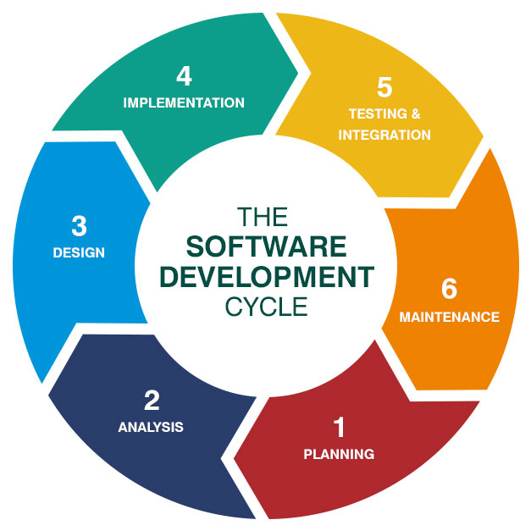

Figure 1: Software Development Lifecycle

  - SYSTEM IMPLEMENTION PLAN
The AntarAalay – AI Powered Interior Design System has been developed following the Software Development Life Cycle (SDLC), a systematic process that guides software creation through defined and sequential phases. This process begins with the planning and requirement analysis phase, where user needs, business goals, technical constraints, and success metrics are gathered and clearly defined to create a foundation for development.

- Planning:
In this phase, all necessary requirements for the system are identified and documented. These include software and hardware specifications, database requirements, and interface needs for the Rakshak application. The goal is to understand user expectations and define clear functional and non-functional requirements that guide the entire development process. This phase ensures that the system addresses real-world women’s safety challenges effectively.

Design:

Based on the gathered requirements, the system architecture and design are developed. The design phase focuses on creating a user-friendly and intuitive interface that ensures ease of use for end users. Various UML diagrams, including Use Case Diagrams, Data Flow Diagrams (DFDs), and Sequence Diagrams, are prepared to represent the flow of data and interactions between system modules. This phase establishes the blueprint for development and ensures that all system components are logically organized.

Implementation:
During the implementation phase, the system design is translated into source code. The AI Powered system is implemented as multiple independent modules such as voice command detection, eye gesture recognition, health monitoring, real-time location tracking, and offline alert communication. Each module is first developed as a small unit, tested for functionality (unit testing), and then integrated into the main system. The implementation ensures that each feature works as intended and aligns with the project objectives.
- Testing:
Testing is performed to validate that the system works as expected and meets all defined requirements. Various test cases are executed to ensure that all modules perform efficiently and produce accurate results within the expected time. After unit testing, all components are integrated and undergo system testing to identify any errors, failures, or performance issues. This phase ensures the overall reliability, stability, and quality of the Rakshak system before deployment.

Integration:

Once the AI-powered interior design system is developed, tested, and ready, the deployment phase begins. In this stage, the system is implemented on the target platform—in this case, the cloud infrastructure supporting the interior design application. Final configurations are made, including integration of key APIs such as Firebase Cloud Messaging for real-time notifications, Twilio for communication, and Google Maps Services for geolocation features. These configurations ensure that the system operates smoothly, efficiently, and securely, providing seamless user experiences.

Maintenance:

After deployment, the system enters the maintenance phase. In this stage, issues encountered in the real-world environment are resolved through patch updates and bug fixes. Additionally, enhancements and feature updates are released periodically to improve performance, add new capabilities, or address newly identified safety needs.
Maintenance ensures that system remains up-to-date, efficient, and capable of adapting to user feedback and evolving technologies.

- SYSTEM DESIGN

  - SYSTEM ARCHITECTURE

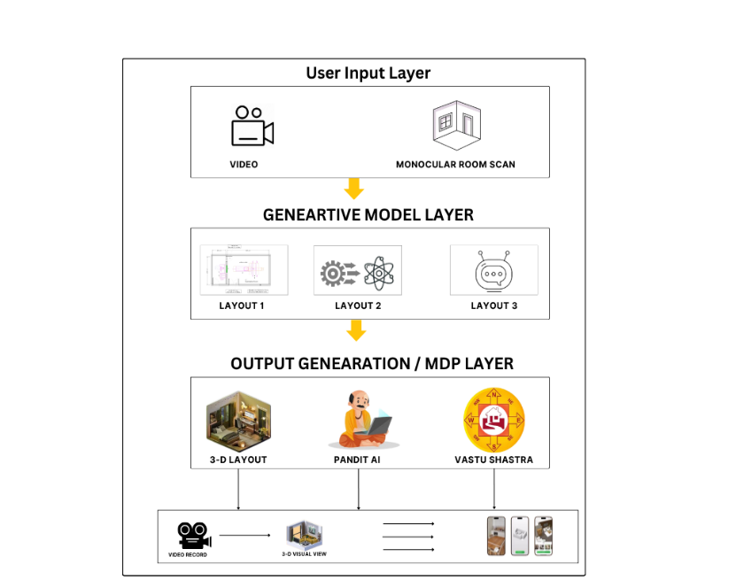
Figure 2: System Architecture of Rakshak

  - DATA FLOW DIAGRAMS
4.2.1 DFD Level 0

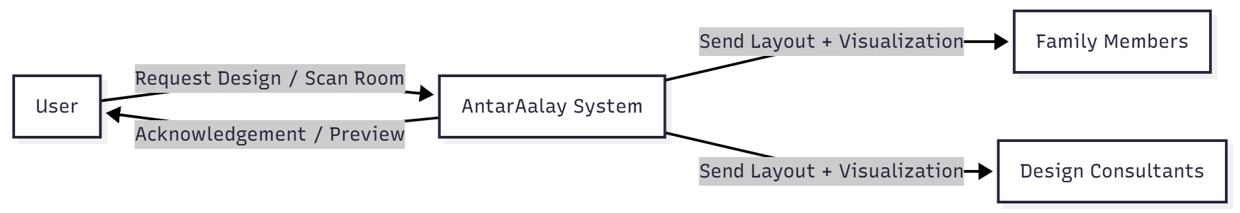

Figure 3: Data Flow Diagram Level 0

4.2.2 DFD Level 1
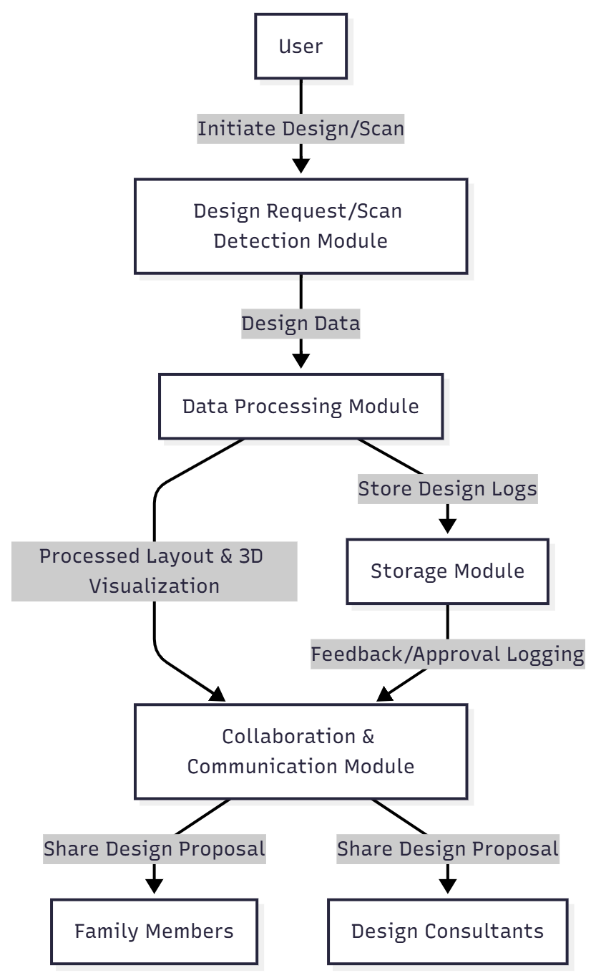
Figure 4: Data Flow Diagram Level 1

4.2.3 DFD Level 2
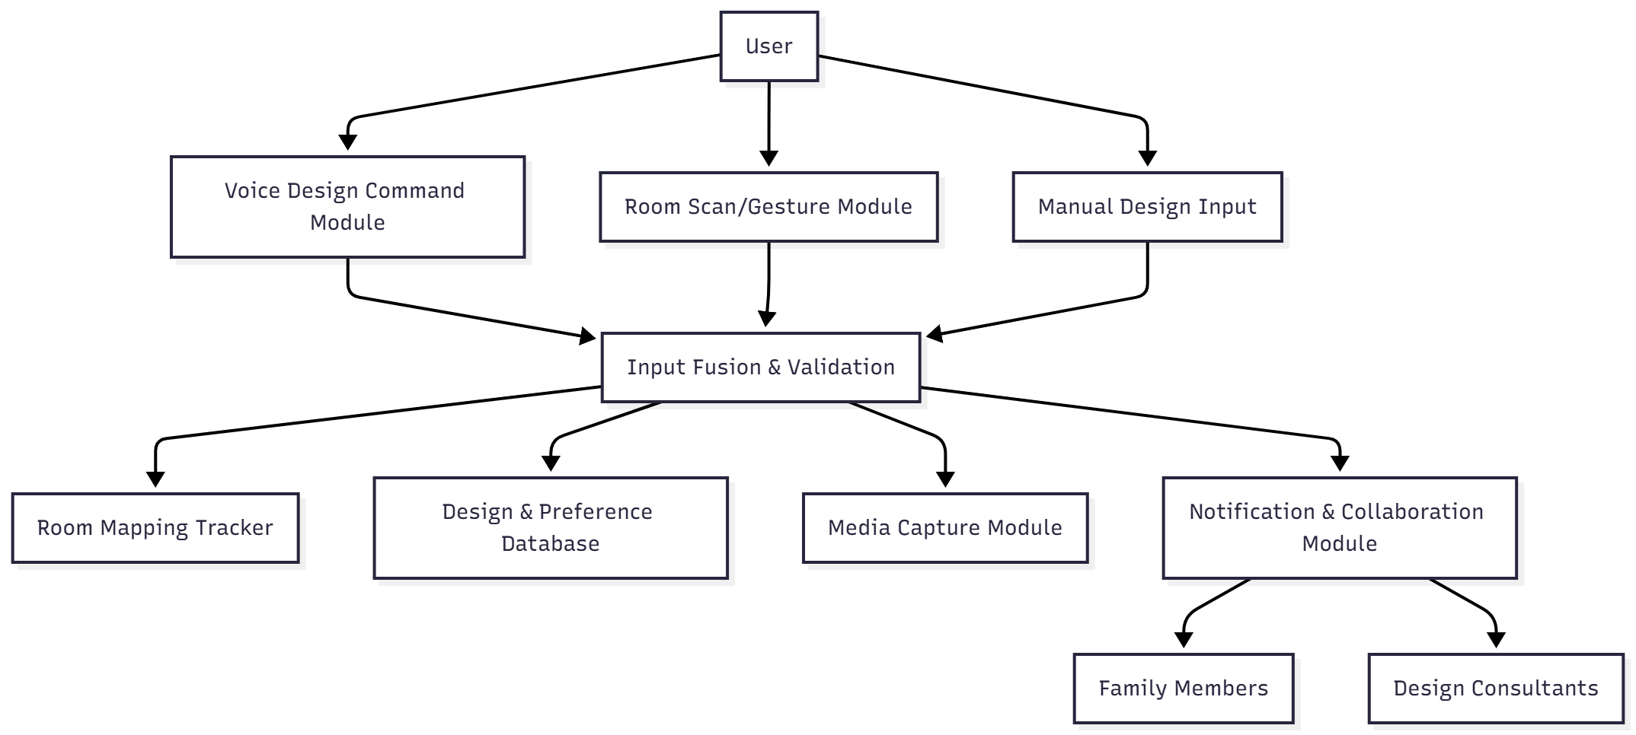
Figure : Data Flow Diagram Level 2

  - ENTITY RELATIONSHIP DIAGRAMS
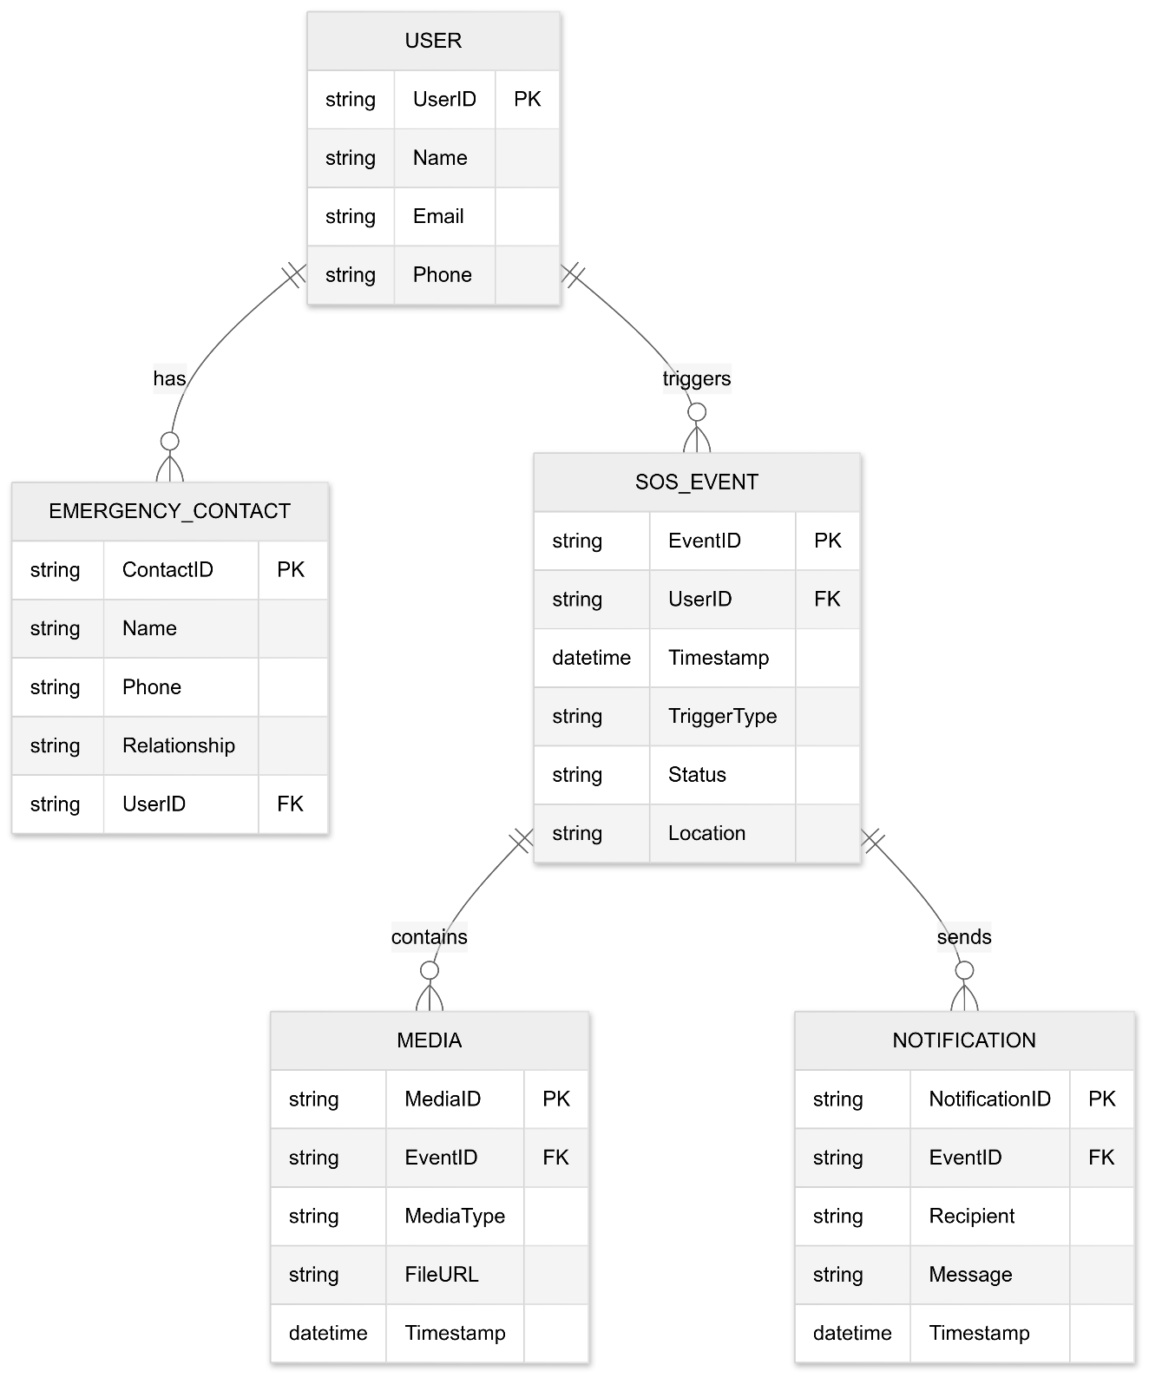

Figure 6: Entity Relationship Diagram of Rakshak

  - UML DIAGRAM

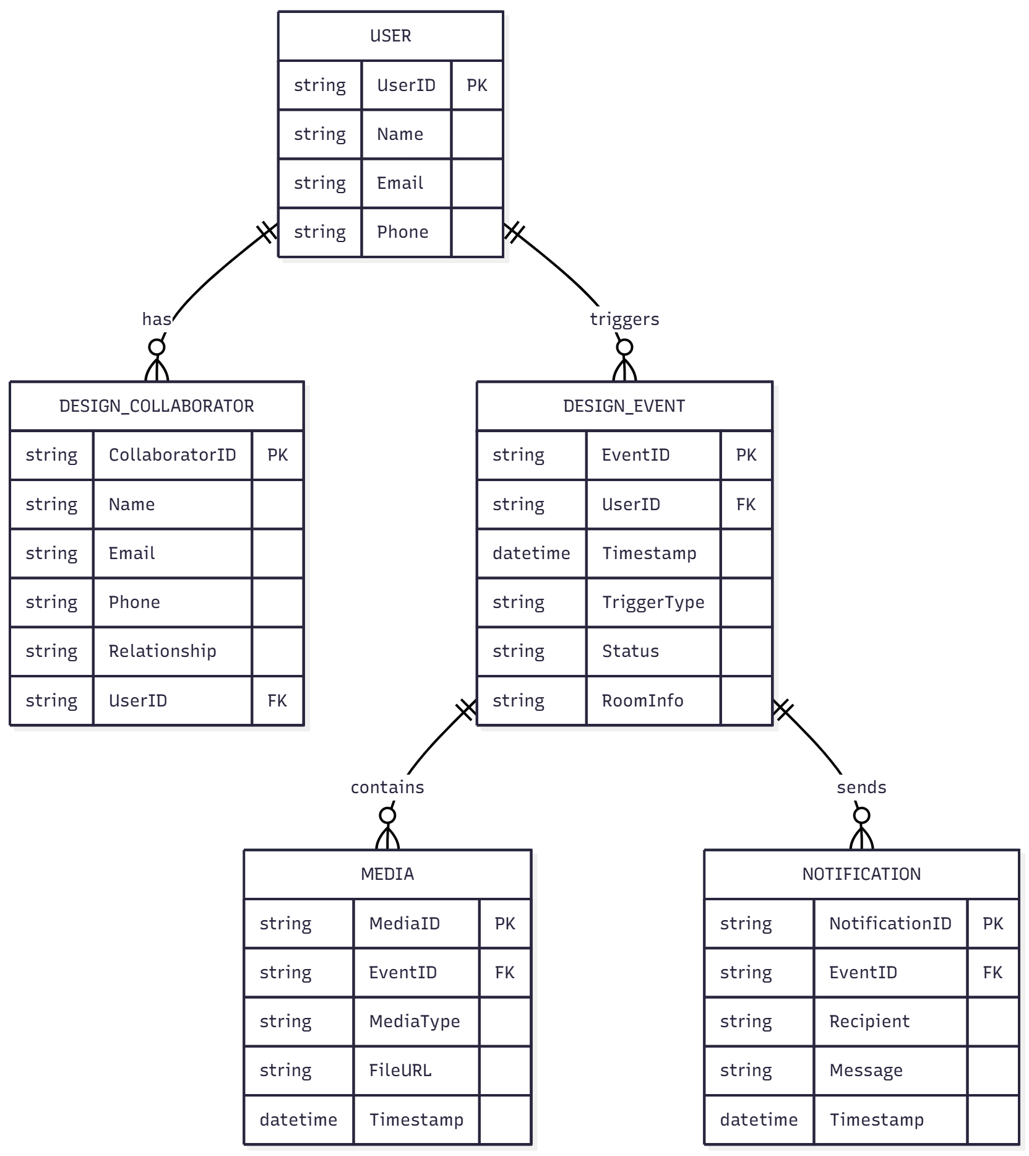
Figure 7: Unified Modelling Language Diagram

  - SEQUENCE DIAGRAM
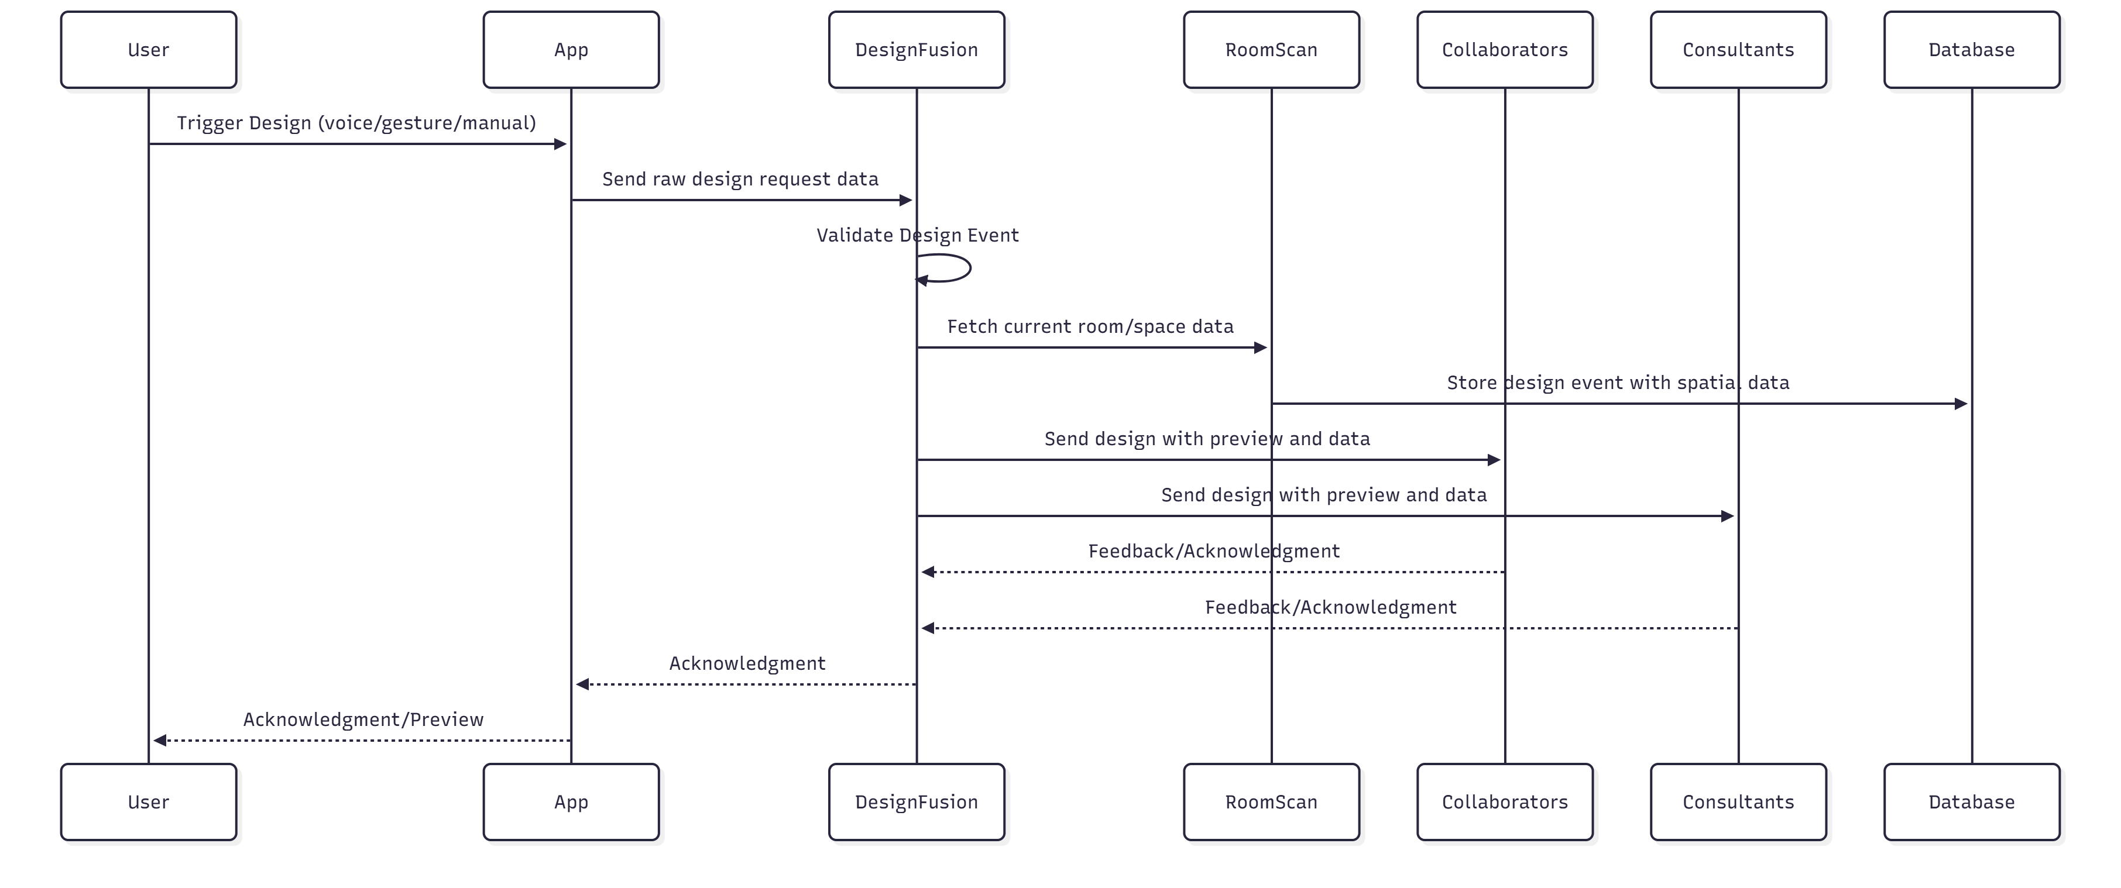
Figure 8: Sequence Diagram of Antaralay.AI

  - ACTIVITY DIAGRAM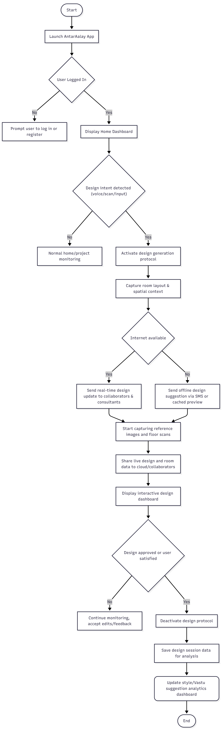

Figure 9: Activity Diagram of Antaralay.AI

- OTHER SPECIFICATION
5.1 ADVANTAGES
- Users can instantly generate or update home designs using multiple intuitive triggers such as voice commands, gestures, or manual selection from the UI.
- Advanced AI algorithms validate user requests and spatial data to ensure only meaningful and practical design changes are suggested, minimizing invalid or unwanted updates.
- The system leverages precise room measurements and layout information to deliver highly personalized interior design plans to users and collaborators.
- If internet connectivity is unavailable, AntarAalay seamlessly provides offline access, allowing users to view cached design suggestions and interact with previously generated layouts.
- All user designs and preferences are encrypted and securely stored, ensuring privacy, data integrity, and trustworthy design collaborations.
- Integration of real-time voice recognition and gesture detection enables a highly interactive, accessible, and user-friendly experience.

5.2 LIMITATIONS
- Users should have a basic understanding of navigation and simple English to interact with design suggestions and controls.
- A compatible device is required, featuring camera support for room scans, accurate location for contextual suggestions, and ideally enhanced sensors for AR-based placement.
- Real-time collaborative features, such as live design sharing and consultant feedback, require an active internet connection, but offline mode allows access to previously saved layouts and basic functionality.
- Voice and gesture-based design features may perform suboptimally in poorly lit or noisy environments, potentially affecting room scanning and command recognition accuracy.

  - APPLICATIONS
- Daily Design Use: Ideal for homeowners, renters, and families to quickly generate, visualize, and collaborate on new interior layouts using convenient triggers such as voice commands, gestures, or manual selection.
- Public & Shared Spaces: Enables rapid redesign and visualization of interiors for offices, educational institutions, and public buildings, making spaces more adaptable and resilient for collaborative work or study scenarios.
- Campus & Workplace: Supports renovation and reorganization in schools, colleges, and workplaces, allowing teams to customize spaces during special events or emergencies requiring layout changes.
- Residential Management: Helps address sudden needs such as accessibility improvements, family health emergencies, or upgrades for safety and comfort through instant design suggestions and AI-powered insights.
- Low-Connectivity Environments: Functions effectively in rural areas or locations with poor internet access by providing offline access to previously saved layouts and design options.

- CONCLUSION & FUTURE WORK
Conclusion:
AntarAalay is an advanced AI-powered interior design system that leverages cutting-edge machine learning and generative technologies to deliver personalized, practical, and aesthetically pleasing home and office designs. It starts by analyzing user inputs such as room photographs, sketches, or 3D models, and intelligently generates multiple design options that adhere to user preferences, functional requirements, and cultural principles like Vastu Shastra.

- AntarAalay is an advanced AI-powered interior design system that leverages cutting-edge machine learning and generative technologies to deliver personalized, practical, and aesthetically pleasing home and office designs. It starts by analyzing user inputs such as room photographs, sketches, or 3D models, and intelligently generates multiple design options that adhere to user preferences, functional requirements, and cultural principles like Vastu Shastra.
- The system supports diverse input types including photos, sketches, and 3D wireframes, allowing users to work with whatever design tools or initial concepts they have.
- AntarAalay uses AI to assess spatial layout, lighting, and material interactions, ensuring realistic and harmonious environments.
- Multiple design styles and moods can be applied, enabling users to explore from minimalistic to luxurious designs.
- The AI optimizes furniture placement and room zoning for enhanced usability, traffic flow, and visual balance.
- Users can interactively select from various photorealistic or conceptual renderings, accelerating decision-making.
- Integrated AR features allow immersive visualization to “walk through” the virtual design in the actual space.
- Collaboration tools enable sharing with family members, designers, or consultants to gather feedback and iterate rapidly.
- The backend securely manages user data and design sessions, maintaining privacy and continuity across devices.

- REFERENCES

1. Karan, E., et al. (2021). Markov Decision Process Workflow for Automating Interior Design. IEEE Transactions on Automation.
2. Thakkar, K., Vadgama, K., Ranawat, K., Sharma, R., & Mangla, M. (2024). Generative AI-Based Interior Designing. IEEE ICEECT.
3. Tumengkol, M. C., & Mantoro, T. (2024). AI Technology for Optimizing Real-Time Work Processes in Interior Design. IEEE ICCED.
4. Hafizah, N., et al. (2025). The Role of Artificial Intelligence in Interior Architecture Design: A Thematic Review. Emerald Insight.
5. Dewi, C. S., et al. (2025). Smart Interior Design System Leveraging ML and AR for Personalization. Springer.
6. Ji, Z., & Yu, Y. (2025). Intelligent Interior Design Systems: Optimizing Layouts and Aesthetics Using AI and User Data. Elsevier
7. Zhang, H., & Li, Y. (2025). AI-Driven Smart Home Design: Insights, Impacts, and Future Directions. Journal of Intelligent Systems and Applications.
8. Sidorova, E., & Novikov, D. (2025). Digital Technologies in Designing and Furnishing Small Residential Spaces: Integration of Economy and Functionality. Procedia Computer Science.
9. Liu, Q., & Wang, J. (2023). The Aided Design of Interior Layout Based on Artificial Intelligence. Journal of Building and Environment Technology.
10. Chen, M., & Zhao, L. (2025). The Interaction Between Technology and Design in Modern Interior Spaces. International Journal of Smart Design and Architecture.

